1. Introduction
   1. Purpose

This document serves to report results from the data collection event held on May 5th 2017. This data collection is in association with the “Walking Incline and Speed Estimator” (WISE) project. The goal of this project is to develop an accurate, simple, and robust method of estimating the walking speed and incline of a human gain using only a single Initial Motion Unit (IMU).

* 1. Collection Objective

The goal of this data collection is to gather IMU data of the human gain cycle at various speeds and inclines, through subjects, to assist in the development of the WISE algorithm. This will allow for development to be as efficient as possible by reducing the need for live algorithm tests. Further, having a larger and more robust data set would allow for a more accurate analysis of the human gait when sampled using the platform of interest.

1. Collection Setup
   1. Platform

For this data collection, the Sparkfun 10736 Inertial Measurement Unit (IMU) was used to sample 6 DOF (3 axis acceleration, 3 axis gyroscope). Recently, Sparkfun has halted manufacturing of the 10736 IMU and therefore this project is expected to instead use the Sparkfun 9250 IMU which will replace the 10736. Unfortunately, the 9250 IMU could not be used for this experiment, as the corresponding code specific to the 9250 was not updated to support the WISE specific algorithms. The reason was, simply, lack of development time.

* 1. Software

For this data collection, the following software version was executed:

|  |  |
| --- | --- |
| Software Title | Sparkfun-9250-9dof-WISE |
| Commit Date | Apr 2, 2017 |
| Commit ID | 7b68210ab93b5f7fb15c4cdacd501c44e46a4617 |
| Parent Commit ID | 9fb79a3b4bdb82416f4bef1fc5ee6cef30a4934d |

This version included initial (untested) WISE specific algorithms, though this functionality was not the focus of this collection. However, after the data was collected, the team could use the data in an emulation mode which would effectively emulate the WISE algorithms. A brief section is included in this report which discusses the performance of the current algorithm.

This version also includes Finite Impulse Response (FIR) and Infinite Impulse Response (IIR) filters which could be applied to the input samples (acceleration & gyroscope). However, for this collection these filters were not applied. In general, the acceleration and gyroscope data was unfiltered (raw) before collection, allowing for future algorithms to be developed without the need to account for the effects of these frequency filters.

* 1. Collection Configuration Parameters

To ensure a robust data set, from which the WISE algorithms will eventually be driven by, data was collected using several variations of parameters.

1. Walking speed [1.8, 2.2, 2.7] (mph)
2. Incline angle [-3, 0, +3, +15] (%)
3. Collection Subject [ ?Becca(1) , CNelser(2), CHarris(3), , EKyle(4)]
4. Results

Because there are multiple dimensions of the data, it would be overly monotonous to analyze every dimension individually. Multiple layers of analysis would yield diminishing returns. Therefore, we will give a brief overview of several features which can be seen in the data and discuss the implications therein.

* 1. DCM Pitch Output

The first, and most intuitive, view of the data is the Directional Cosine Matrix (DCM) filter pitch output. This is, of course, the first layer of the algorithm from which much of the remaining layers will be built. Looking at the DCM outputs we can get a simplistic look at the performance of the algorithm.

It is important to remind the reader that for this collection all frequency filters which operated on the raw input data (acceleration and gyroscope data) were deactivated to preserve the quality of the data for future development.

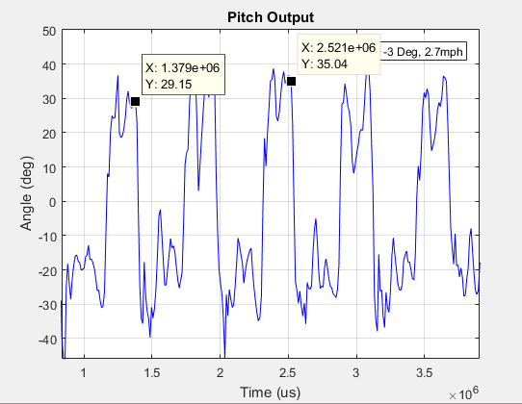

Fig. 1: Pitch Output, Becca, 2.7mph, -3deg

As we can see, the algorithm appears to be functional. Without much effort, we can clearly distinguish by eye each gait cycle. There does seem to be quite a bit of noise, however, the noise is not so great to destroy the data.

For later use, let us empirically determine the frequency (in Hz) for the data in Fig.1. To do so, we simply need to find the inverse of peak to peak time, which turns out to be about 1.785 Hz.

* 1. Spectral Distribution and Analysis

Another significant, and intuitive, indicator of the quality of the data would be the spectral distribution of the data. The spectral distribution, here, refers to the frequency distribution after applying the Fourier Transform to the output pitch data. Ideally, we would hope to see a distribution in which the only frequency present is that which corresponds to the human gait. Unfortunately, there is always noise and this case is no exception! However, the spectral distribution will show us where the noise “lives”.

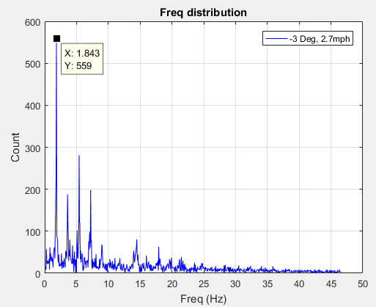

Fig. 2: Spectral Distribution, Becca, 2.7mph, -3deg

As we can see in Fig.2, the frequency corresponding to the human gain is about 1.84 Hz. Recall, we previously calculated the frequency to be about 1.785 using the peak to peak time in the pitch data. We can thus say our results match.

Now we must consider the higher frequency peaks. As it turns out, these are the frequencies of the predominant noise. For this case, the top 6 noise peaks correspond to frequencies (ordered from low freq. to high) 3.6Hz, 5.4Hz, 7.2Hz, 9.0 Hz, 14.5 Hz, and 17.9Hz.

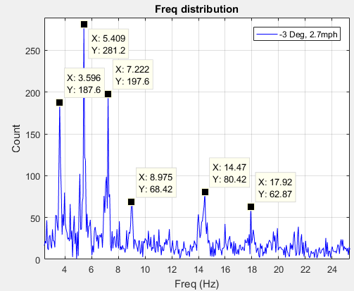

Fig. 3: Spectral Distribution of Noise, Becca, 2.7mph, -3deg

Interestingly, if we look at the distribution of noise frequencies as functions of the gait frequency (i.e. the distribution of (freq_noise / freq_gait) ) we find that the noise falls fairly consistently on whole numbers 2:11 ( that is, 2xfreq_gait, 3xfreq_gait … etc.). This strongly indicates that the noise is harmonic in nature.

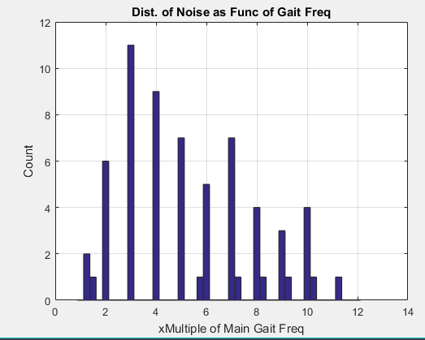

Fig. 4: Distribution of Noise as Function of Gait Frequency

* 1. Gait Frequency Correlative Properties

As stated in the introduction, the goal is to find a way to determine the walking speed and incline of a subject using only the IMU data. With this aim, let us determine the properties of the data which corollate strongly with these two dimensions.

* + 1. Gait Frequency vs Speed

First, let us look at the relationship between the walking speed of the subject and the gait frequency per incline angle for subject 1. This will give us a picture of how the walking speed is correlated to the gait frequency.

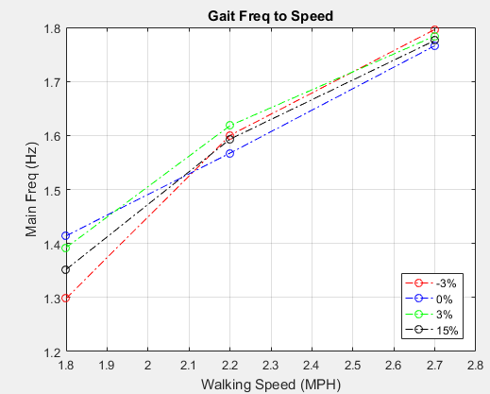

Fig. 5: Gait Freq vs Walking Speed per Incline, Subject 1

Here we can conclude that there is a strong correlation between the walking speed and the gait frequency. This result was expected.

The figure above (Fig. 5) is for a single subject. To demonstrate the significance of this point, let us now show how this result changes across this alternative dimension.

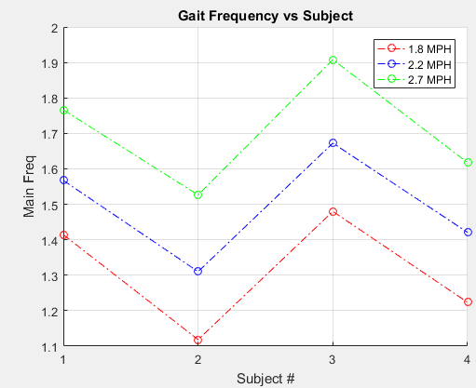

Fig. 6: Gait Freq vs Subject, Incline 0%

Clearly the subject can change the result dramatically. This is to be expected as each subject has their own stride length and unique gait.

In this section, we have shown that there is a strong correlation between the gait frequency and walking speed. However, we have also demonstrated that this correlation is highly dependent on the subject. Therefore, gait frequency alone cannot be used to determine walking speed.

* + 1. Gait Frequency vs. Incline Angle

Note: This section has been skipped because the author was running a little short on time and determined that this section did not provide much notable insight. Data is available and can be provided if requested. Bottom line information can be found in Appendix C (Incline Estimator Results), which contains data resulting from the estimator evaluation conducted in section 4.2.

1. Postprocessing and Emulation

To determine the effectiveness of the WISE algorithm, an offline emulator was developed which could use the data collected in this report to evaluate the WISE specific algorithms. Many of the algorithm parameters can be set and used in the emulator. In the following section, we will analyze velocity and incline estimation algorithms.

* 1. Velocity Estimation

The current velocity estimator is a simple integrator using the input acceleration data from the IMU. The caveat here is the acceleration data is uncorrected. I.e. We use the DCM filter to get (relatively accurate) Euler angles. However, because we have chosen to use an integration approach to the velocity estimation, we must use the raw acceleration data to properly integrate. Further, we must account for the bias introduced from gravity on acceleration. Further iteration may also include the roll angle in the calculation for even further refined data, however this is not included here.

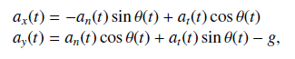

Eq. 1-2 [REF] – Integration of acceleration, accounting for gravity bias

Overall, we found that there is a significant amount of drift introduced when integrating. This is to be expected as this is often the case with integrators. The immediate solution is to “reset” the integrator at some boundary condition, which in this case is the end of each gait cycle.

Initially, the vertical most point was used to determine the end of the gait. I.e. when the leg breaks vertical. However, this proved to be a very erroneous solution as the gait cycle is not symmetric. This created a significant error in the velocity estimates.

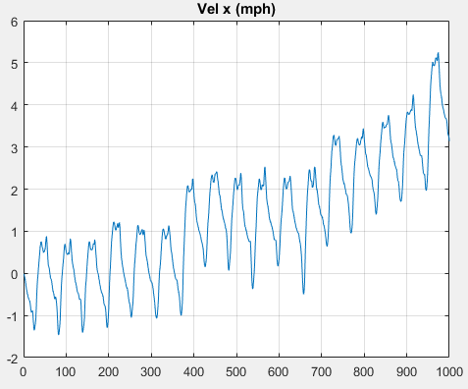 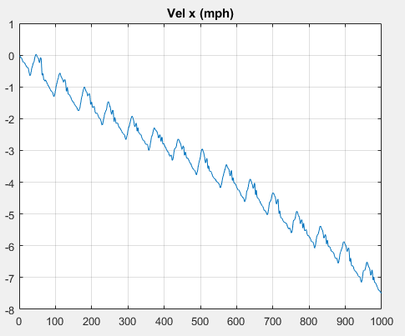  
Fig. 9,10: Velocity Examples showing drift (before correction), Vel vs Sample No.  
Becca,1.8mph,0% Right   
ChrisH,2.7mph,15% Left

Instead, we decided to create an algorithm which would detect (with as high accuracy as possible) the point of minimum pitch (toe off). Intuitively, this would be a point where the velocity is zero, or as minimal as possible, after which the velocity quickly increases. This point is clearly seen in the Figs.9,10 as the minimum of each gait cycle.

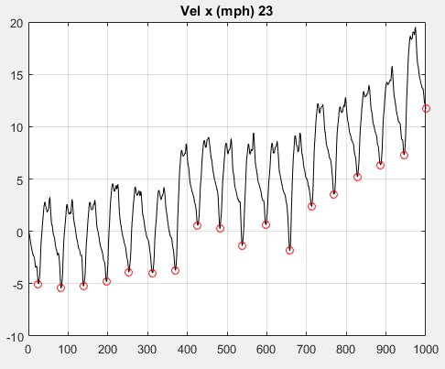

Fig. 11: Velocity vs Sample No. with gait mapped,  
ChrisH,2.7mph,15%

Using any method, we determine the local minima for each gait cycle. From the corresponding data, we can determine the average drift and adjust the data by an appropriate (linear) scaling factor. The result is a gait cycle where the acceleration is forced to integrate to zero.

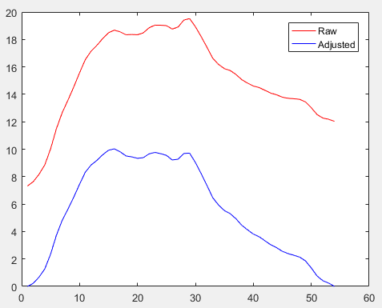

Fig. 12. Adjusted Velocity Profile,  
ChrisH,2.7mph,15%,  
Gait Cycle No. 14

Now we may find the average velocity over the gait to come up with our best velocity estimate. For the current version of the code, the Estimator is accurate to within 0.8 mph (over all data collections). Notably, we tend to preform much worse at higher incline. In addition, error seems to be highly correlated with the test subject. See Tables 1,2,3 in Appendix B for further details.

* 1. Incline Estimation

The current Incline estimator boils down to a simple arctan formulation. What we do is integrate the velocity in both x and y to get the relative displacement. Once we have displacement in each x and y, we can find the angle of incline by finding the ratio between them.

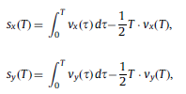  
Eq. 3,4 [REF] - Integration of velocity.

Note that the secondary term in our integration (Eq 3&4) is a drift correction term described in the previous section. Quite simply, it is subtracting the ending velocity to account for drift. In our implementation, however, we instead subtract a linear scaling of the slope [ ((v(T)-v(0))/(T) * n)-v(0) ], we found that this was a better approximation for the drift.

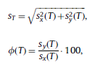  
Eq. 5,6 [REF] – Stride Length and Slope

Implementing the algorithm proved to be a fair amount more complicated, however, as the y velocity had a far lower signal to noise ratio. I.e. The magnitude of the velocity in y was very small. This caused the drift correction and integration algorithms to be far more difficult to determine.

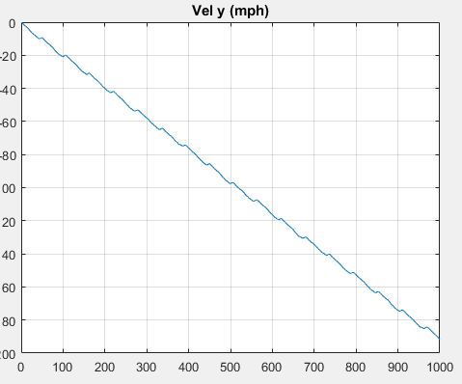 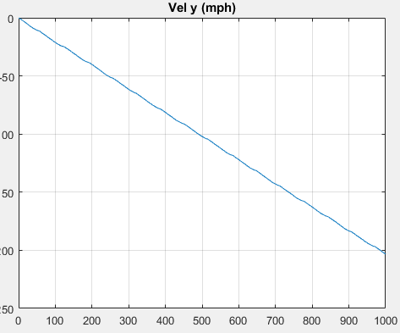  
Fig. 13 – Y Velocity (before correction), Vel vs Sample No.  
Becca,1.8mph,0% Right   
ChrisH,2.7mph,15% Left

The small Signal to Noise Ratio (SNR) results in very poor drift estimation and removal. However, reasonable estimation was achieved by taking input from the x-velocity drift correction. This makes intuitive sense as the two velocities are inherently coupled and share the same underlying gait.

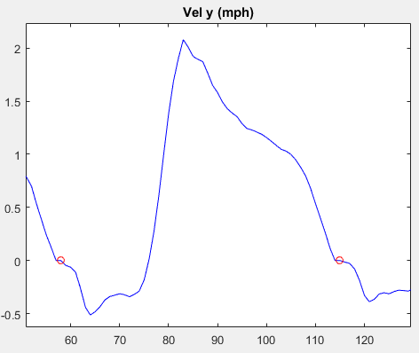  
Fig. 14 – Corrected Velocity,  
ChrisH,2.7mph,15%

After drift correction, the velocity looks closer to how we may expect. The position of the toe off event (marked in red), which we could determine in the drift correction in X, appears off from where we may expect. It is not known if there is an underlying reasoning behind this discrepancy.

The results (detailed in Appendix C) are not as positive as we might hope. Overall, the walking incline is, on average, 12% in error. This error is highly correlated with incline. The estimator tends to do much better at higher inclines (any incline away from 0%). This would make intuitive sense as at 0% incline all Ay acceleration is in error. Future algorithms will need to be adjusted to account for this effect though no solution is presented here.

1. Appendix A – Data Collection Parameters

|  |  |  |  |
| --- | --- | --- | --- |
| Subject Name | Incline Angle (%) | Walking Speed (mph) | File Name |
| Becca | 1.8 | 0 | Subject1_1p8_0pct.txt |
| Becca | 2.2 | 0 | Subject1_2p2_0pct.txt |
| Becca | 2.7 | 0 | Subject1_2p7_0pct.txt |
| Becca | 2.2 | +3 | Becca_2p2_ p3pct.txt |
| Becca | 1.8 | +3 | Becca_1p8_ p3pct.txt |
| Becca | 2.7 | +3 | Becca_2p7_p3pct.txt |
| Becca | 2.2 | +15 | Becca_2p2_p15pct.txt |
| Becca | 2.7 | +15 | Becca_2p7_p15pct.txt |
| Becca | 1.8 | +15 | Becca_1p8_p15ct.txt |
| Becca | 2.7 | -3 | Becca_2p7_n3ct.txt |
| Becca | 1.8 | -3 | Becca_1p8_n3ct.txt |
| Becca | 2.2 | -3 | Becca_2p2_n3pct.txt |
| Nelser | 1.8 | +3 |  |
| Nelser | 2.7 | +3 |  |
| Nelser | 2.2 | +3 |  |
| Nelser | 2.7 | -3 |  |
| Nelser | 2.2 | -3 |  |
| Nelser | 1.8 | -3 |  |
| Nelser | 2.7 | 0 |  |
| Nelser | 2.2 | 0 |  |
| Nelser | 1.8 |  |  |
| Nelser | 2.2 | +15 |  |
| Nelser | 1.8 | +15 |  |
| Nelser | 2.7 | +15 |  |
| Kyle | 2.2 | 0 |  |
| Kyle | 1.8 | 0 |  |
| Kyle | 2.7 | 0 |  |
| Kyle | 2.7 | -3 |  |
| Kyle | 1.8 | -3 |  |
| Kyle | 2.2 | -3 |  |
| Kyle | 1.8 | +15 |  |
| Kyle | 2.2 | +15 |  |
| Kyle | 2.7 | +15 |  |
| Kyle | 2.2 | +3 |  |
| Kyle | 2.7 | +3 |  |
| Kyle | 2.2 | +3 |  |
| Harris | 1.8 | +15 |  |
| Harris | 2.7 | +15 |  |
| Harris | 2.2 | +15 |  |
| Harris | 2.7 | -3 |  |
| Harris | 2.2 | -3 |  |
| Harris | 1.8 | -3 |  |
| Harris | 2.2 | +3 |  |
| Harris | 2.7 | +3 |  |
| Harris | 1.8 | +3 |  |
| Harris | 2.2 | 0 |  |
| Harris | 1.8 | 0 |  |
| Harris | 2.7 | 0 |  |

**Table 1. Collections**

1. Appendix B – Walking Speed Estimator Results

  
Table 1: Error Across Speed

  
Table 2: Error Across Incline

Table 3: Error Across Subject

1. Appendix C – Walking Incline Estimator Results

  
Table 4: Error Across Speed

  
Table 5: Error Across Incline

Table 6: Error Across Subject